|  |  |  |  |
| --- | --- | --- | --- |
|  | Bansilal Ramnath Agarwal Charitable Trust's  Vishwakarma Institute of Information Technology  **Department of**  **Artificial Intelligence and Data Science** | | |
| Name: Siddhesh Dilip Khairnar | | | |
| Class: TY | Division: B | | Roll No: 372028 |
| Semester: V | | Academic Year: 2023-2024 | |
| Subject Name & Code: Cloud Computing & Analytics: ADUA31203 | | | |
| Title of Assignment: Write IAC using terraform to create EC2 machine on AWS. | | | |

**ASSIGNMENT NO. 5**

**Terraform file(before execution):**







**CODE:**

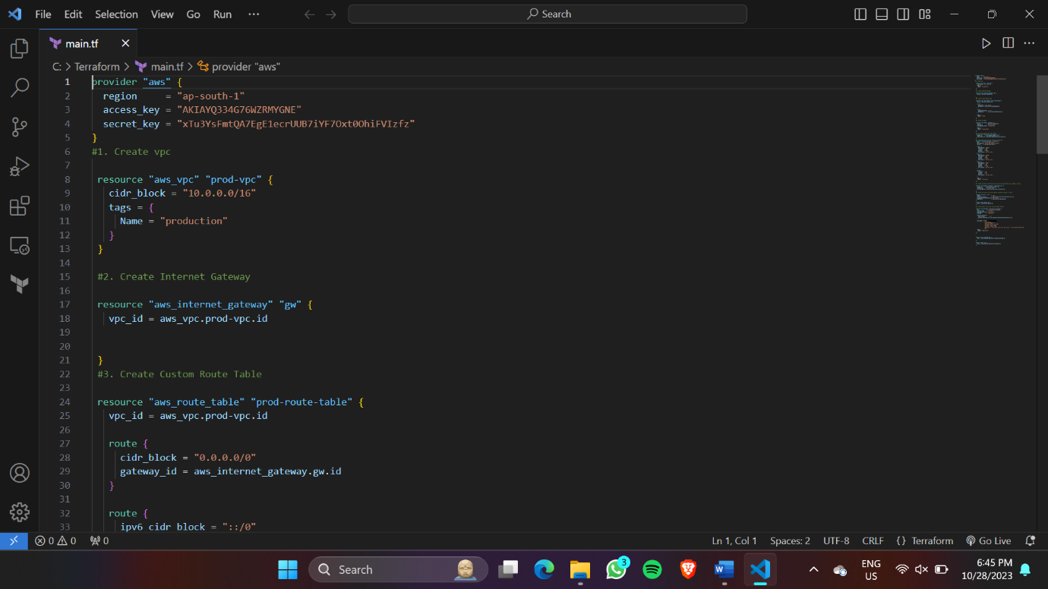

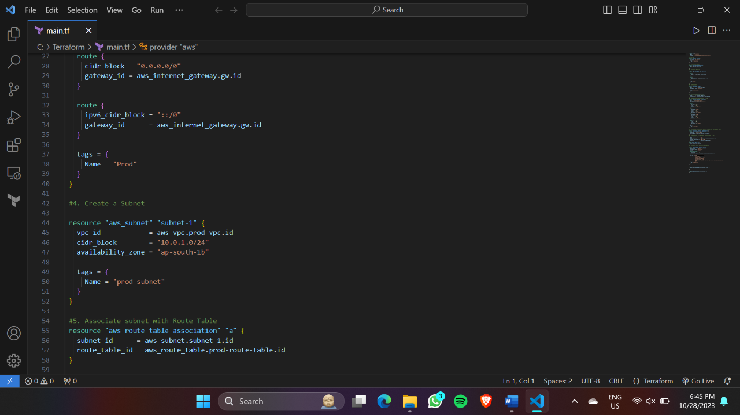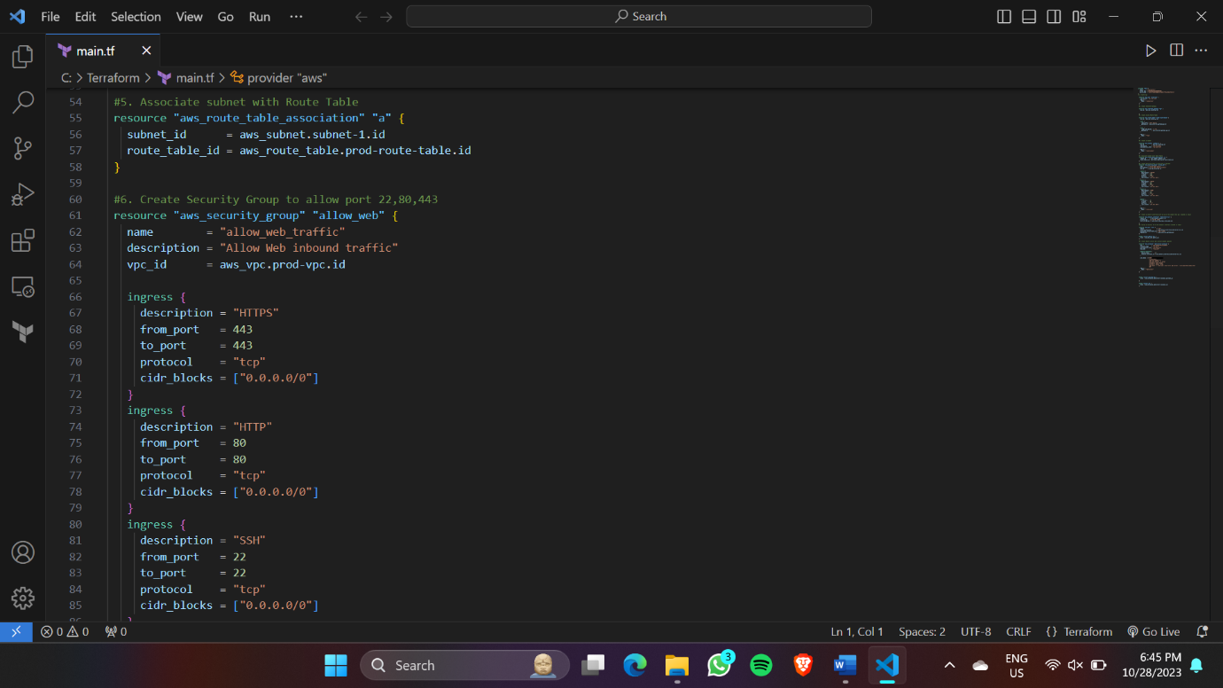

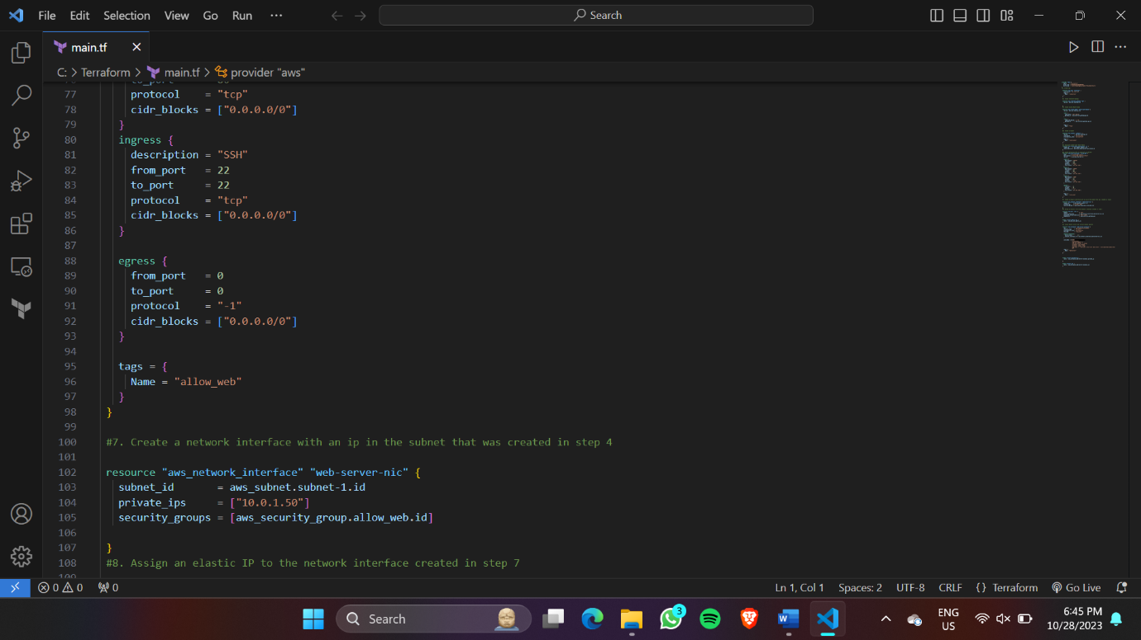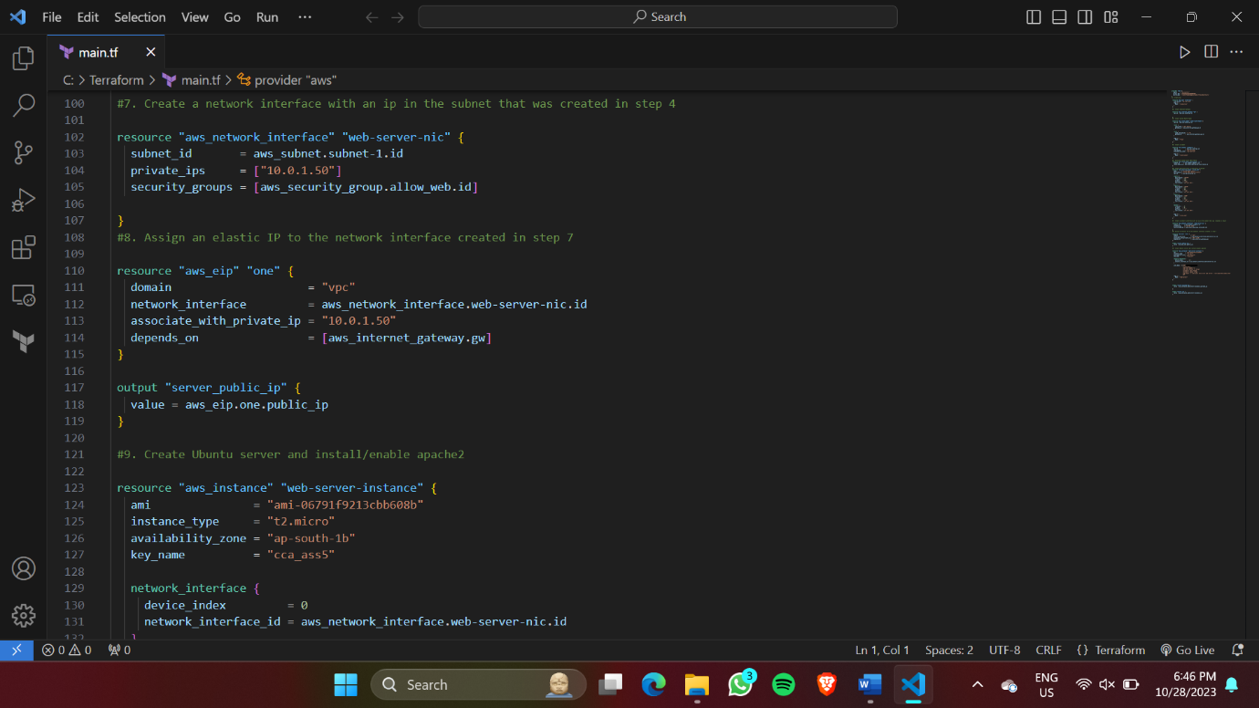

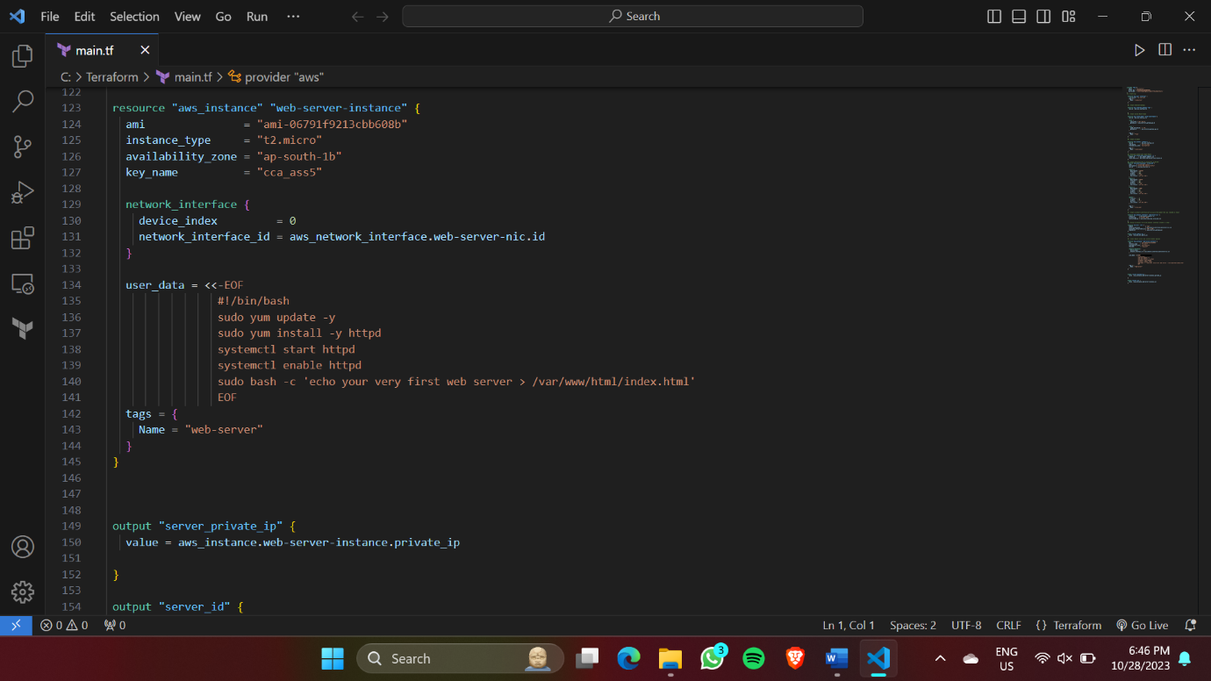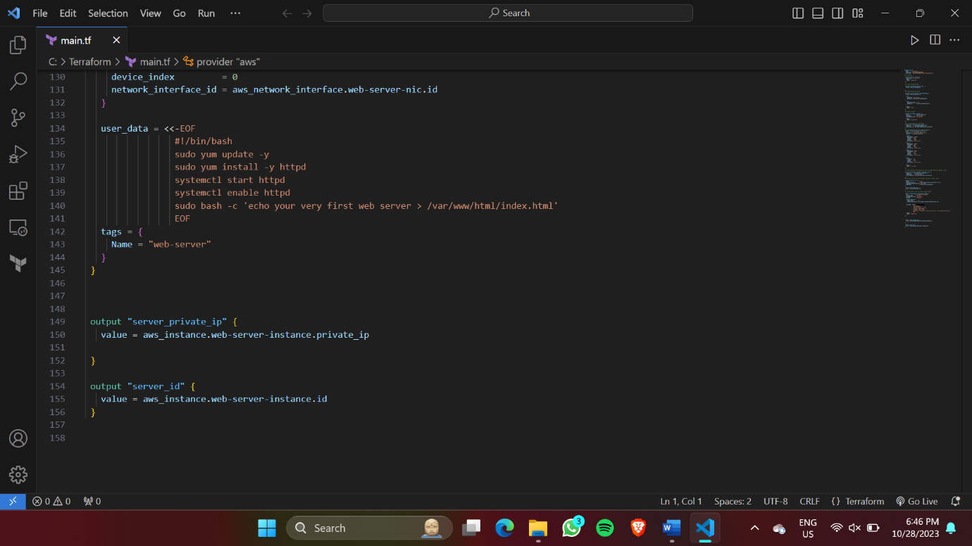

**Terraform Commands:**

* Terraform init:

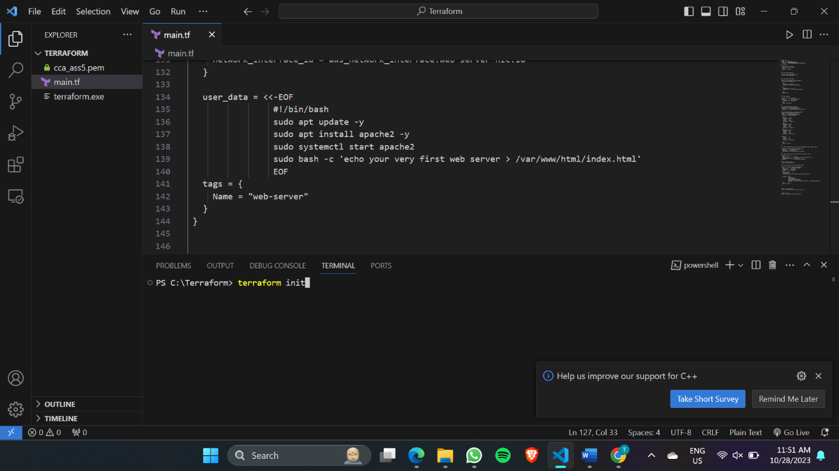

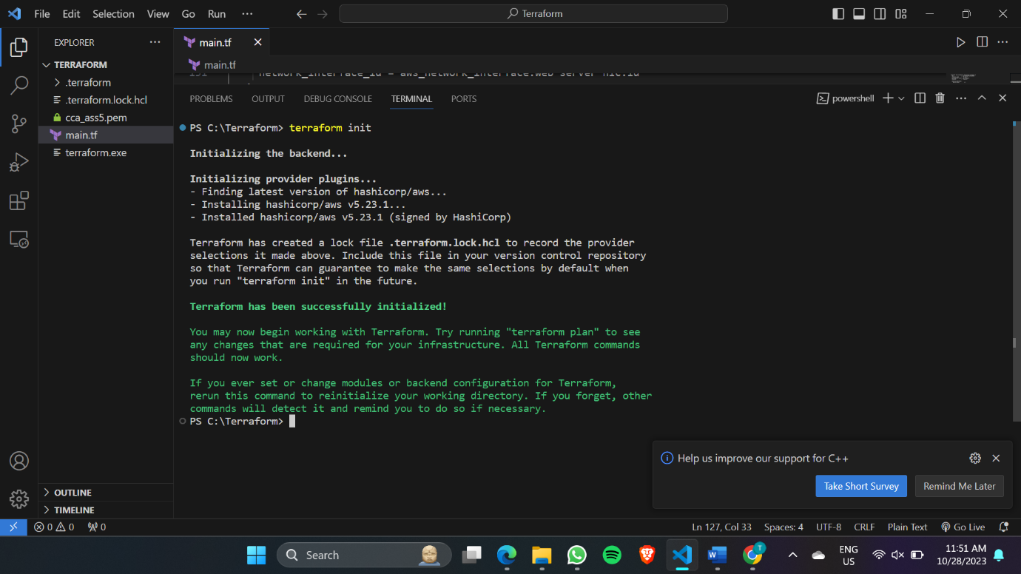

* Terraform plan:

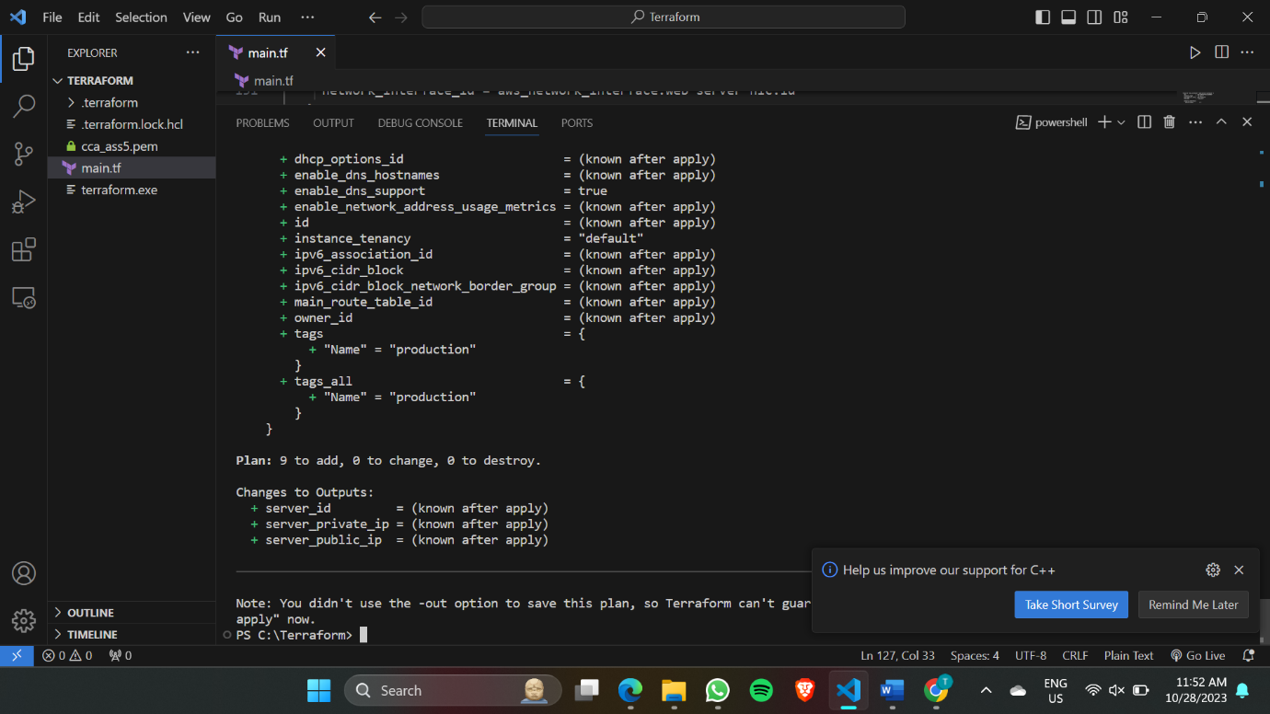

* Terraform apply:

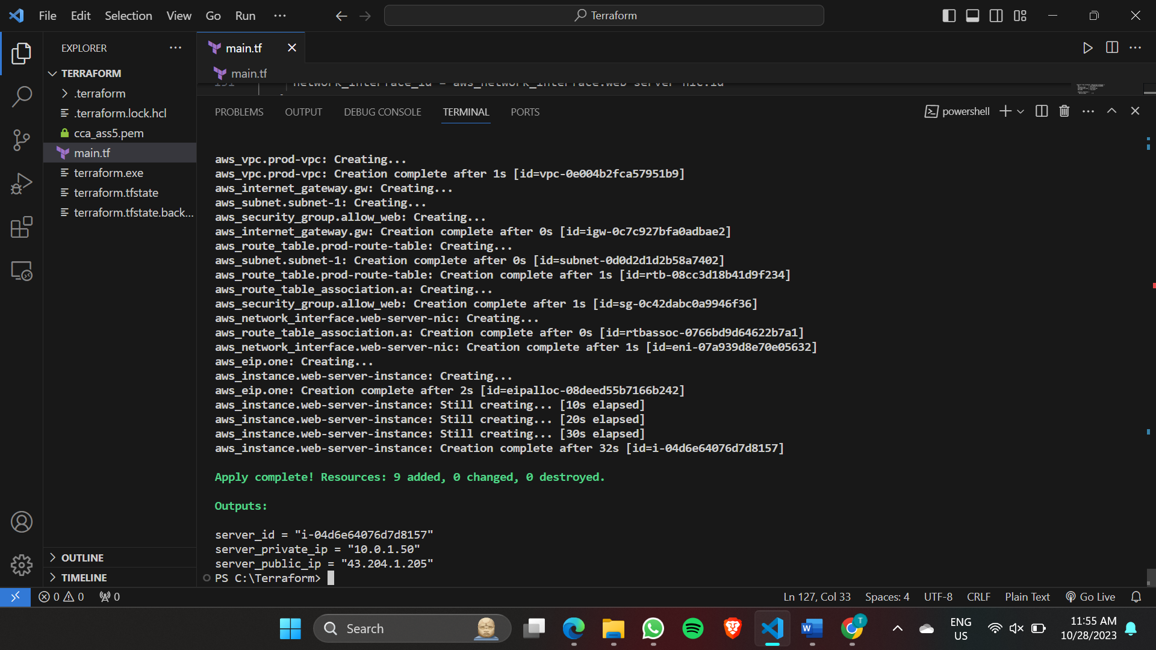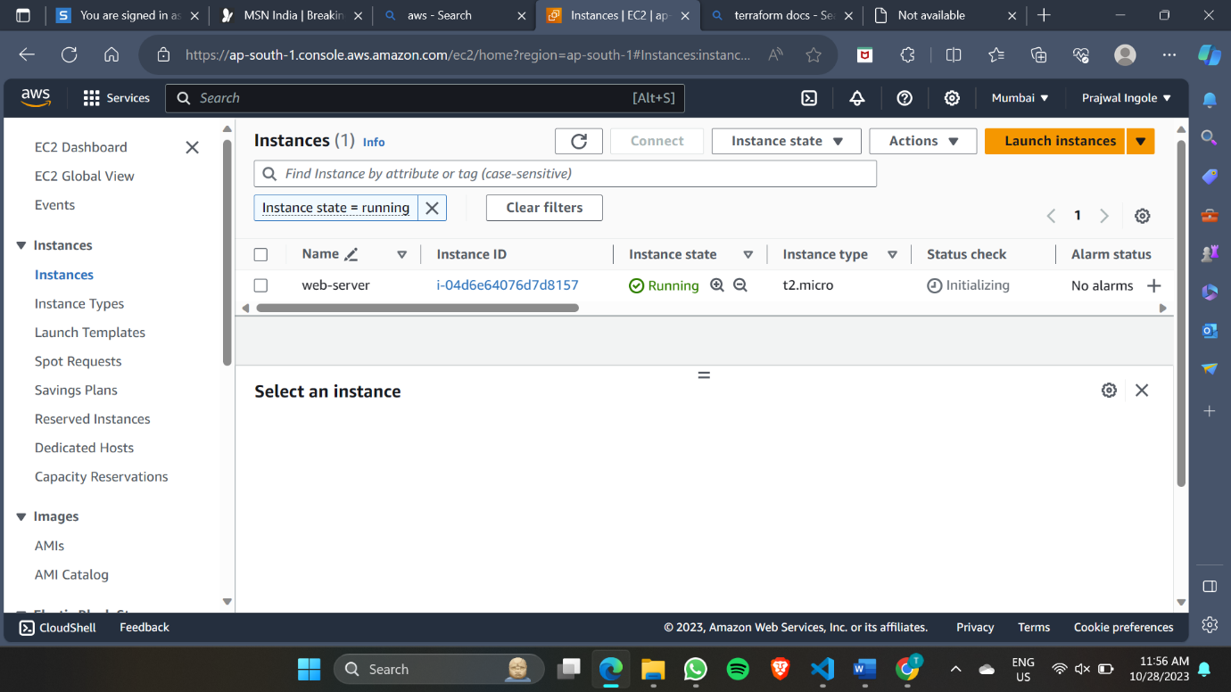

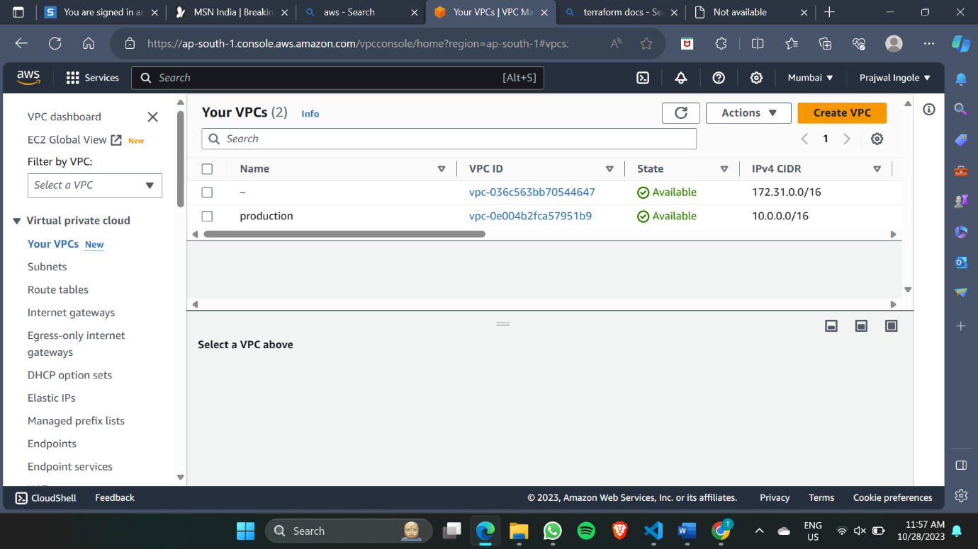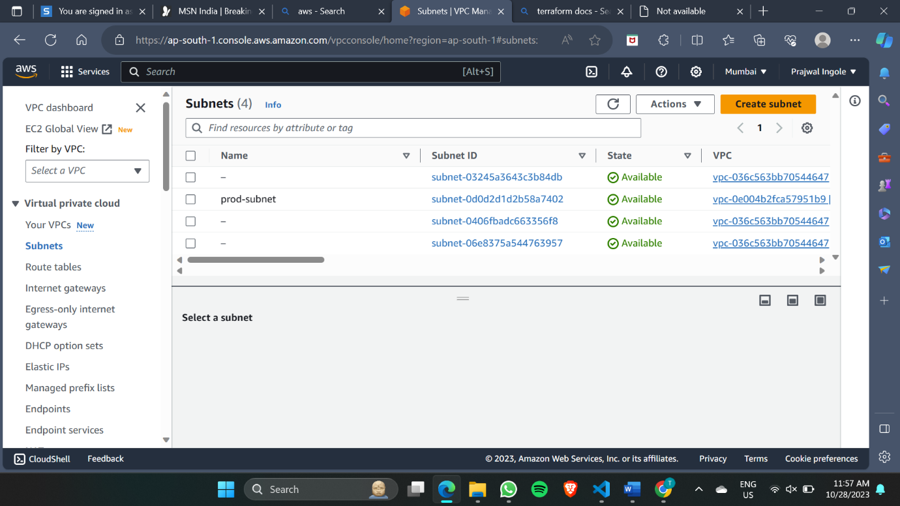

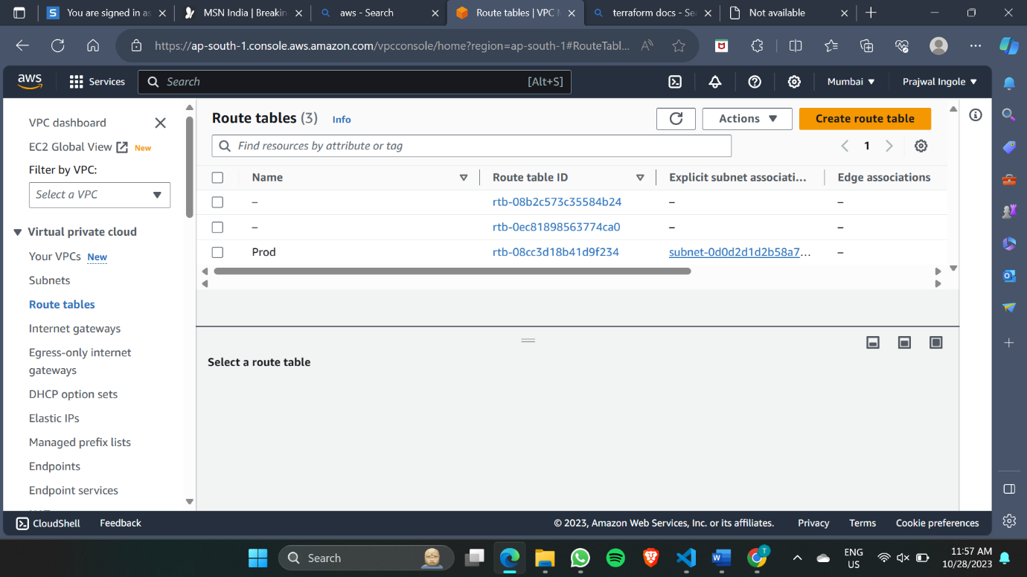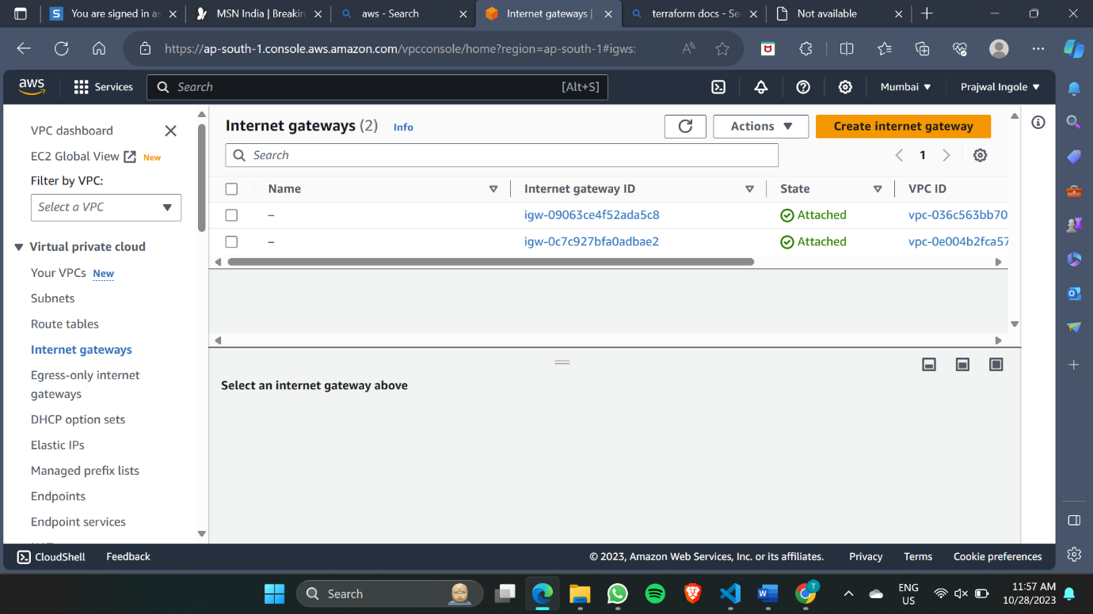

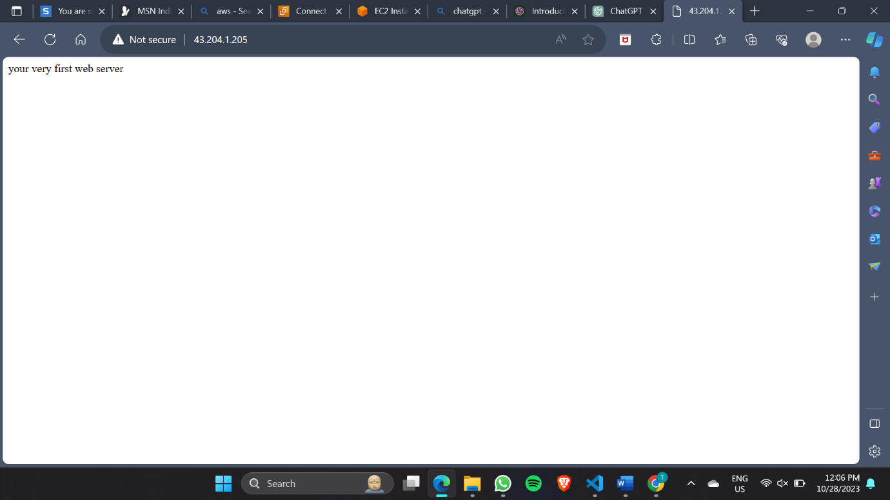

* Terraform destroy:

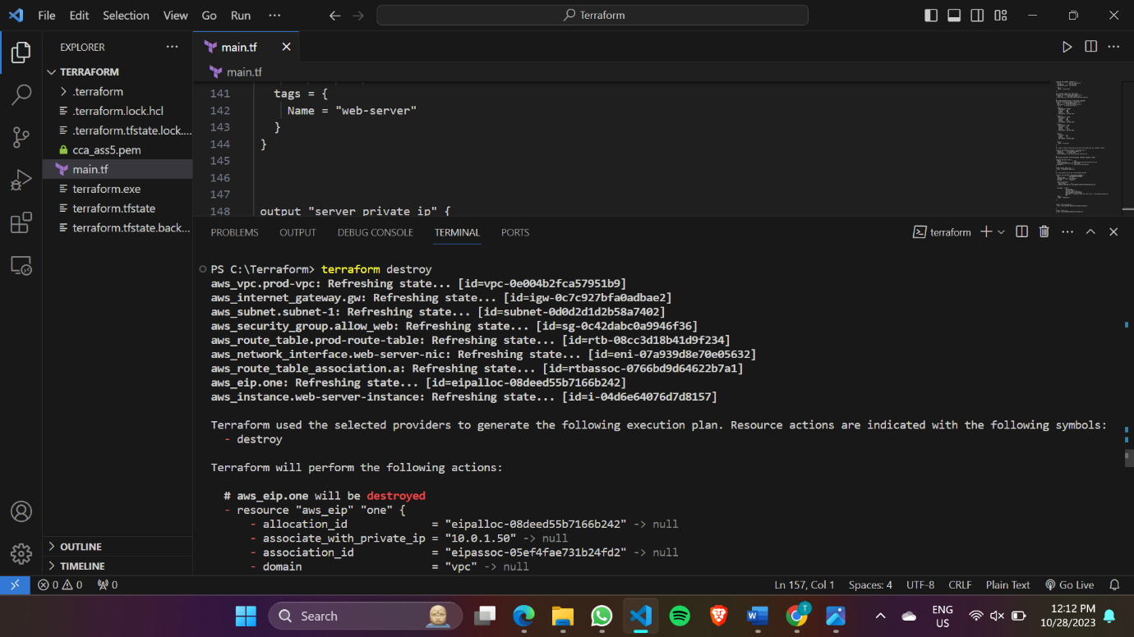

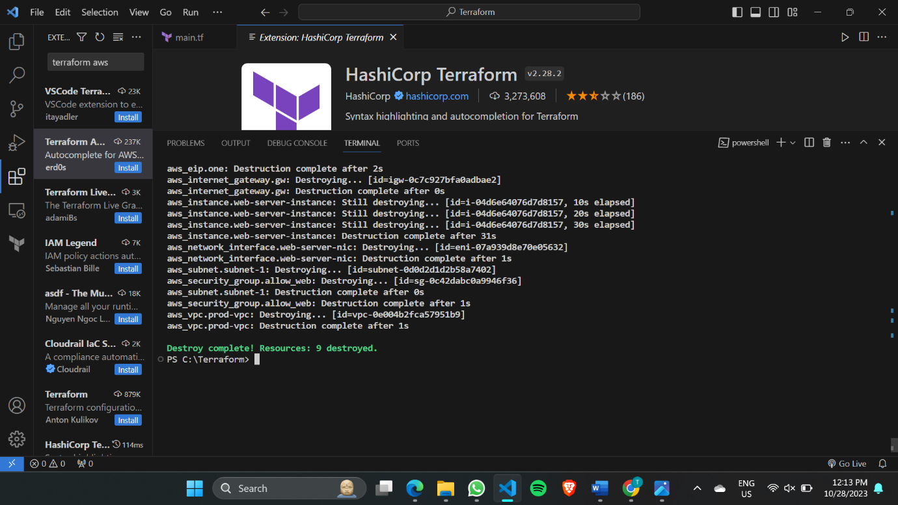

**Terraform file (after execution):**

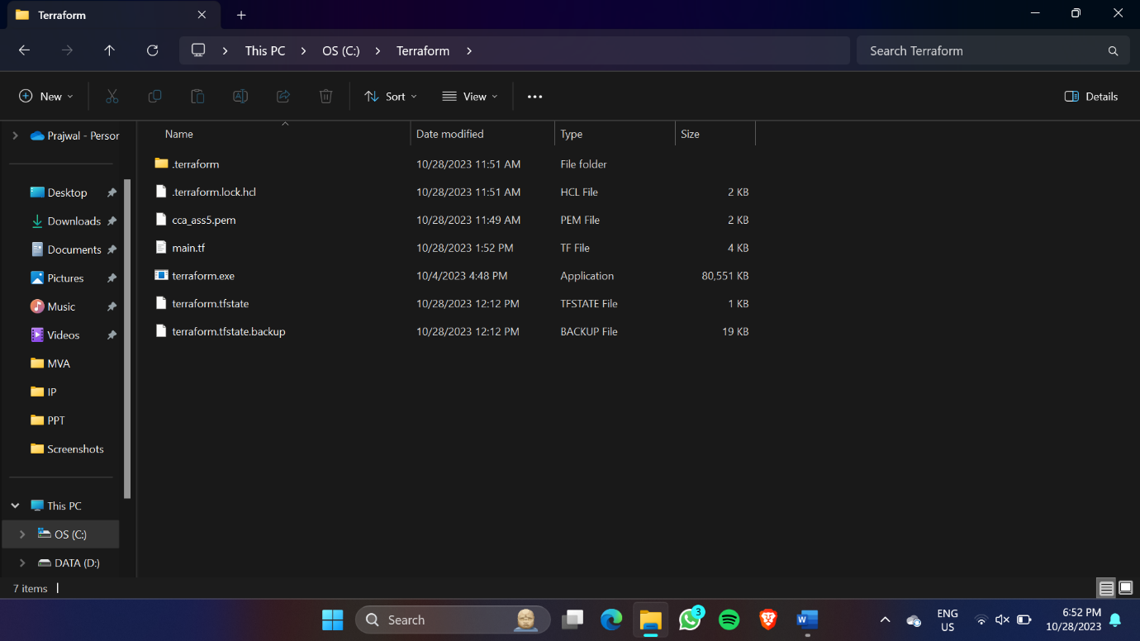

# Conclusion: Thus, we have successfully Write IAC using terraform to create EC2 machine on AWS.